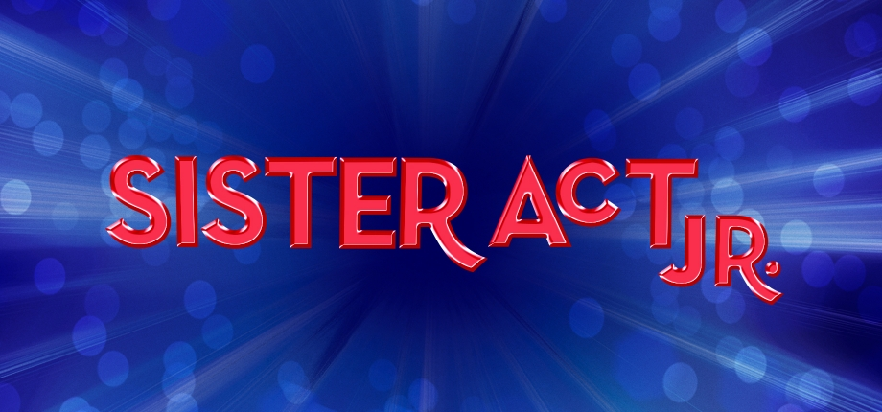
Deloris Van Cartier- A strong, street- wise aspiring singer who gets caught up with the wrong crowd. When she witnesses a crime involving her ex-boyfriend, she is put in witness protection – as a nun! Deloris is reluctant at first, but the more time she spends at the convent, the more she realizes that time with the sisters is exactly what she needed. Cast a great actress and wonderful singer in this powerhouse role. Gender: Female Vocal range top: E5 - G3
Tina - One of Deloris’s backup singers. These featured roles are perfect for enthusiastic performers who may not be quite ready to take on a larger role. Cast solid, good singers who are comfortable with speaking lines in this fun girl group! (And feel free to add these actors to your nun ensemble later in the show Gender: Female Vocal range: Db5 - Ab3
Nina - One of Deloris’s backup singers. These featured roles are perfect for enthusiastic performers who may not be quite ready to take on a larger role. Cast solid, good singers who are comfortable with speaking lines in this fun girl group! (And feel free to add these actors to your nun ensemble later in the show.) Gender: Female Vocal range: Db5 - Ab3
Elle - One of Deloris’s backup singers. These featured roles are perfect for enthusiastic performers who may not be quite ready to take on a larger role. Cast solid, good singers who are comfortable with speaking lines in this fun girl group! (And feel free to add these actors to your nun ensemble later in the show.) Gender: Female Vocal range: Db5 - Ab3
Michelle- One of Deloris’s backup singers. These featured roles are perfect for enthusiastic performers who may not be quite ready to take on a larger role. Cast solid, good singers who are comfortable with speaking lines in this fun girl group! (And feel free to add these actors to your nun ensemble later in the show.) Gender: Female Vocal range: Db5 - Ab3
Curtis Jackson - To put it frankly, a complete jerk. He’s not only mean and dishonest, he’s also dangerous – and he’s got Deloris on his radar. Curtis does not sing a solo, so cast a fantastic actor in this role who can play the bad guy. Gender: Male
Joey - The wise guy of Curtis’s group. He’s an upbeat charmer who is always ready with a joke – even though he’s one of Curtis’s criminals. Cast a charismatic, funny actor with a great singing voice. Gender: Male Vocal range: B3 - D3
TJ- Not the brightest bulb in the bunch, and the audience is meant to have a few laughs at his expense. Cast a solid comedic actor who has great chemistry onstage with Joey and Pablo. Gender: Male
Pablo - The strong, silent type who definitely leans into his role as the muscle of the group. He has a few lines and sings some, but most importantly, he should make a great third member of the trio with Joey and TJ. Gender: Male
Ernie - One of Curtis’s thugs and, unfortunately, takes the fall for being a police informant. This is a featured role for a good actor! Feel free to double Ernie as an Altar Boy or the Monsignor O’Hara later in the show if your program is short on male actors – just make sure that the audience won’t confuse the characters if they are played by the same person. Gender: Male
Cop - The first person to talk to Deloris about Ernie’s murder. This is a featured role for a performer who may be new to stage.
Eddie Southern - The quintessential good guy with a heart of gold. Though Eddie was overlooked by Deloris in high school, he never quite got over his crush on her, which results in a few awkwardly endearing moments throughout the show. Cast an excellent actor, singer, and dancer who can portray this hardworking, sweet cop. Gender: Male Vocal range: F4 - Ab2
Mother Superior - Devoted leader of the convent. Her church and her sisters come before all else – and she’s not afraid to voice her opinion. Mother Superior means well and eventually comes around regarding Deloris. Mother Superior is a major role, so look for an excellent singer/actress who can portray this strong, independent woman. Gender: F. Vocal range: D5 - A3
Monsignor O'Hara - The charming spiritual leader of the Queen of Angels Cathedral. His bottom line is to save their church, and he will do anything to support the bottom line – including forcing Mother Superior to house Deloris. Monsignor O’Hara should have a good stage presence and a sense of comic timing. He does not sing a solo in the show, so cast an actor with charisma who can take over the stage! Gender: Male
Mary Patrick - A nun in the convent. She is an upbeat, over-the-top, enthusiastic person who is always looking on the bright side. She has a number of solos within songs, so cast a good singer and actor in this fun role. Gender: Female Vocal range : E5 - A3
Mary Robert - A postulant and the youngest of the abbey’s inhabitants. Shy, soft- spoken, and a bit of a wallflower, she enjoys being a nun, but her friendship with Deloris lets her truly find her voice. Cast a powerhouse singer and a great actor in this role. Gender: Female Vocal range: E5 - A3
Mary Lazarus- One of the older nuns at the convent, and she leads the choir. She is rather deadpan and not particularly welcoming to Deloris at first, though Deloris’s love of music eventually wins her over. Cast a great character actor with a sense of comic timing who is comfortable with character singing. Gender: Female Vocal range : C5 - G3
Mary Martin-Of-Tours - A nun who definitely exists in her own world, so cast a good actor in this role that can make strong character choices. This nun has some wonderful stand-out moments, which include delivering an excellent karate chop, but she does not sing a solo, so cast someone who is a stronger actor than singer for this memorable role. Gender: Female
Mary Celeste - Mary Celeste and Mary Irene are the convent’s cooks. They have a few featured solos, so cast confident singers in these roles. Gender: Female Vocal range: D5 - B3
Mary Irene - Mary Celeste and Mary Irene are the convent’s cooks. They have a few featured solos, so cast confident singers in these roles. Gender: Female Vocal range: D5 - C4
Mary Stephen - A nun in the convent with a fantastic singing voice. She’s supportive of Deloris’s music from the start. Cast a great singer. Gender: Female Vocal range: E5 - C4
Mary Theresa - The oldest nun in the convent. She has a few featured lines and a small solo. This role is a great opportunity for someone new to the stage, so cast a good actor in this role who is comfortable singing in a group. Gender: Female Vocal range: B4 - D4
Nuns - The Nuns (including Nun 1, Nun 2, and Nun 3) help fill out of the world of the convent. Nun 1, Nun 2, and Nun 3 have featured solos, so be sure to cast actors in these roles that are ready for their moment in the spotlight. Gender: Female Vocal range: D5 - G4
Ensemble - Roles include: Nuns, Altar Boys, Street People, Angry Street Person, and Members of the Congregation

